NEXTAG

Developer guide

## 

| Supervisor | Miss Fariha Shafiq | |
| --- | --- | --- |
| Batch. | 2410F1 | |
| Group. | A | |
| Serial No. | Enrollment No | Name |
| 1 | 1610219 | Ahmad Ur Rehamn |
| 2 | 1610500 | Farooq Daniyal |
| 3 | 1613926 | M. Arman |
| 4 | 1612275 | Abdullah Sardar |

## 

# Project Overview:

NEXTAG is a **modern e-commerce platform** focused on **handbags, wallets, backpacks, and accessories** from luxury brands. This developer guide provides insights into the **technical structure, navigation, and core functionalities** of the website.

## **Project Structure:**

NEXTAG is developed using the following technologies:

**Frontend:** HTML5, CSS, JavaScript, Bootstrap

**Librairies & Plug-ins:** jQuery, Owl Carousel (for sliders), FontAwesome (icons)

**Deployment:** Optimized for **desktop, tablet, and mobile devices**

# Home Page (index.html)

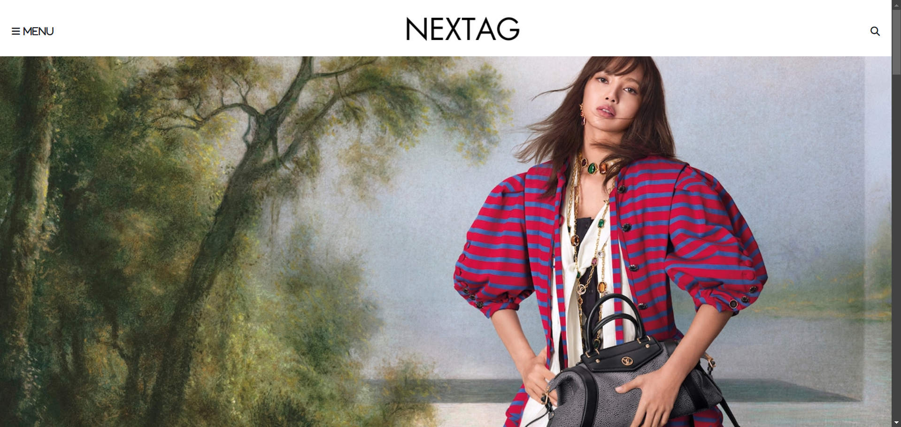

***Figure 1: Navbar***

My navbar enhances user experience by providing easy access to website sections, ensuring seamless navigation.

**Code of Navbar:**

# Screenshot 2025-03-15 232332

# -Feature Products:

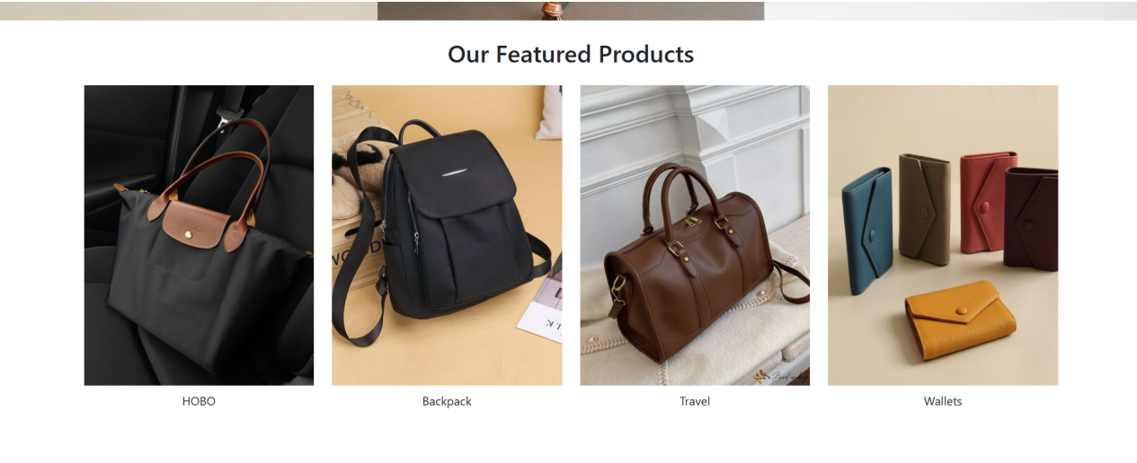

This section shows our best selling products

# Code of Feature Products:

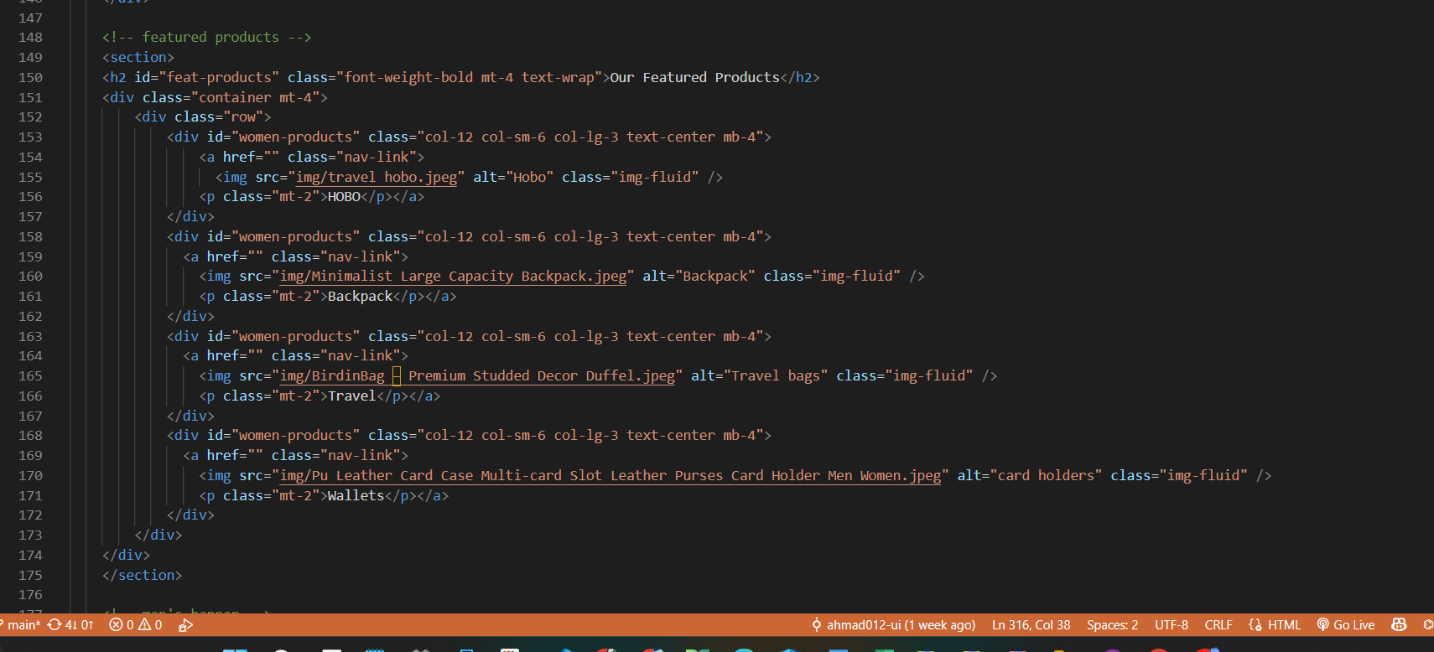

# Off Canvas For Menu:

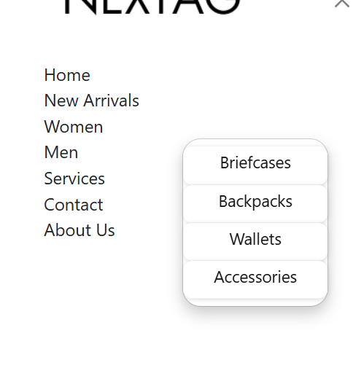

This section showcase all our pages

# Code for Menu:

# Screenshot 2025-03-15 234601Screenshot 2025-03-15 234619

# ****Service section:****

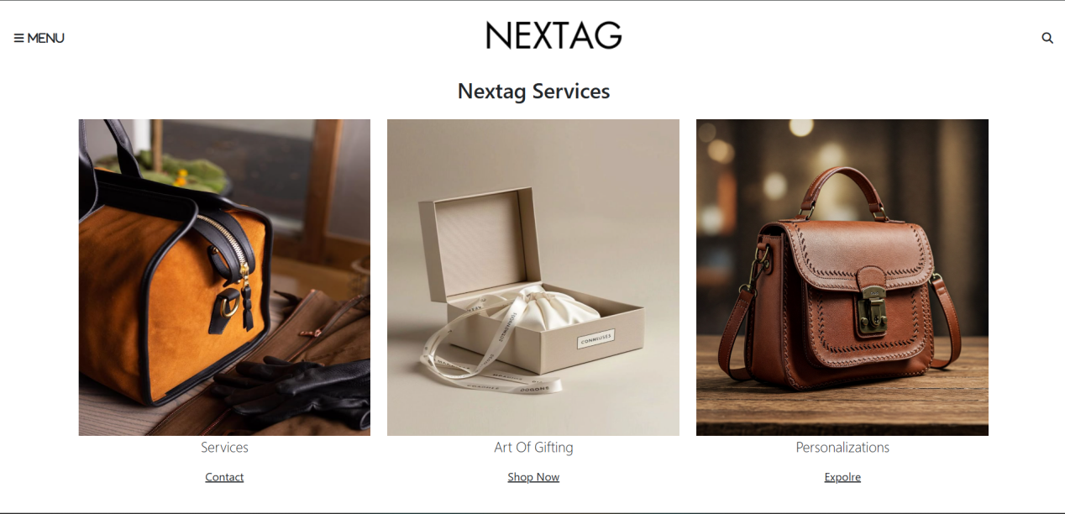

This section showcases the services NEXTAG providing

# Code of service section:

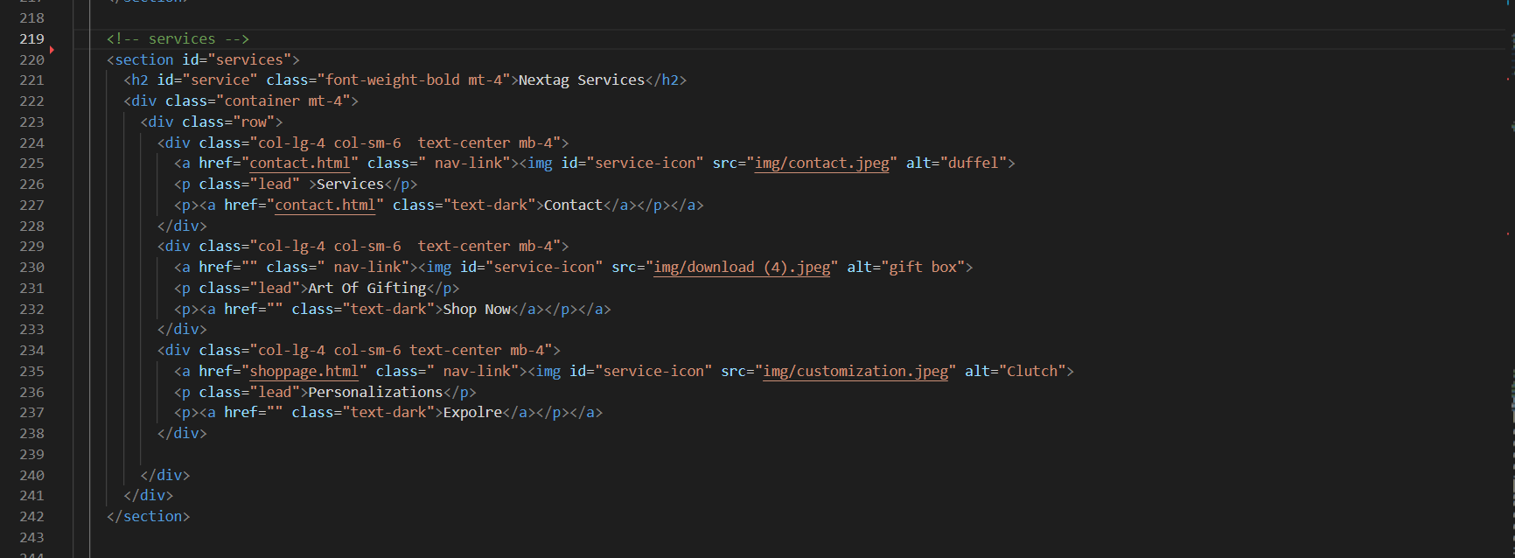

# Footer:

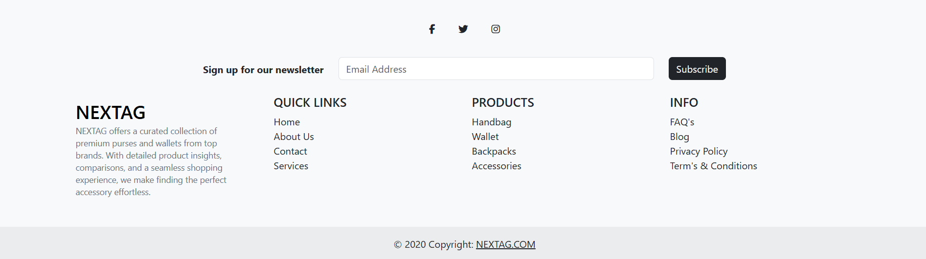

Our Footer has all the links and pages NEXTAG have

# Code Of Footer:

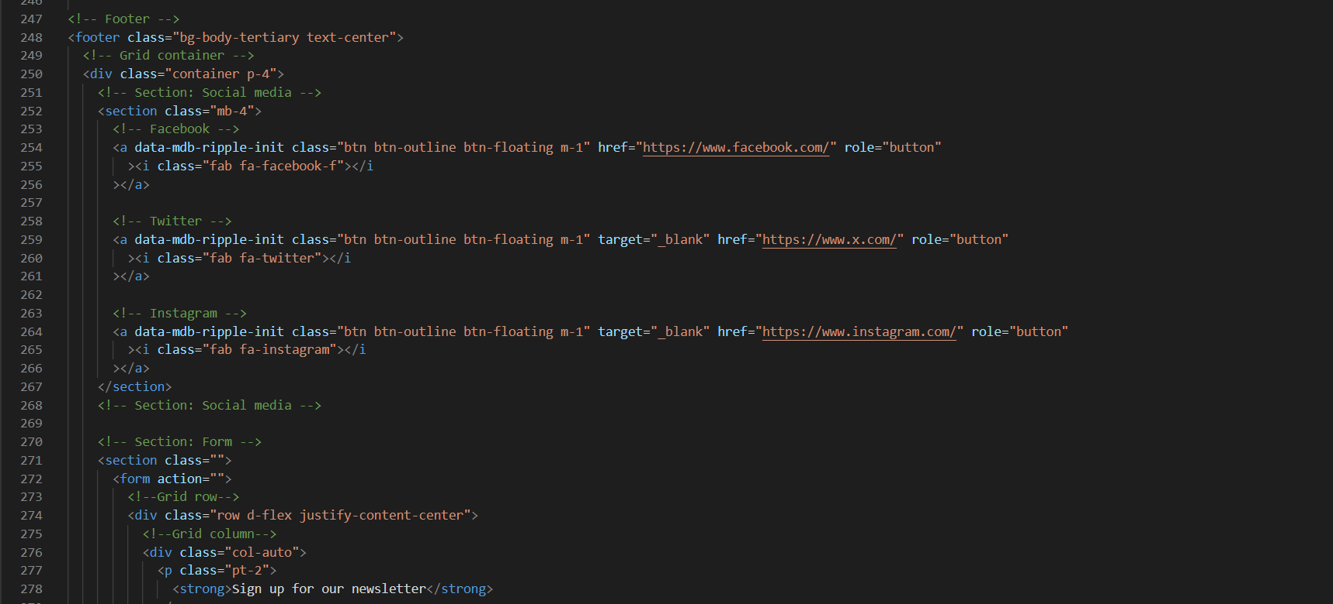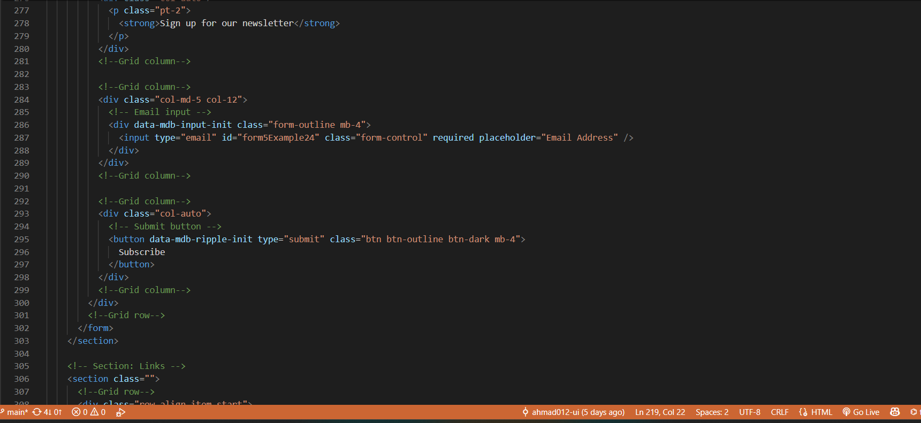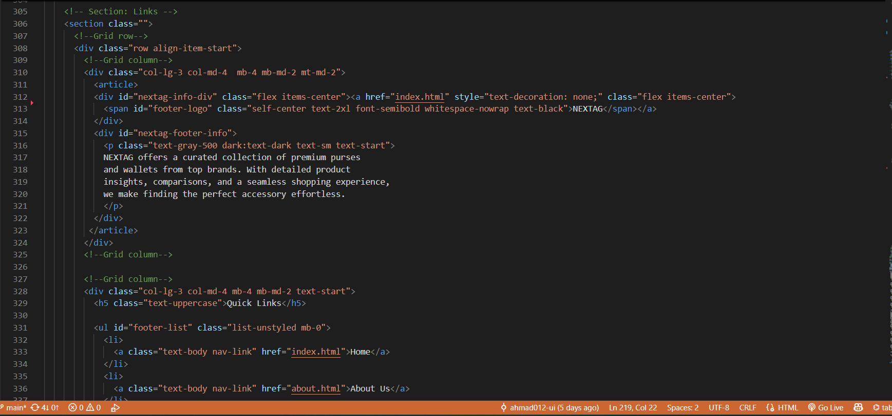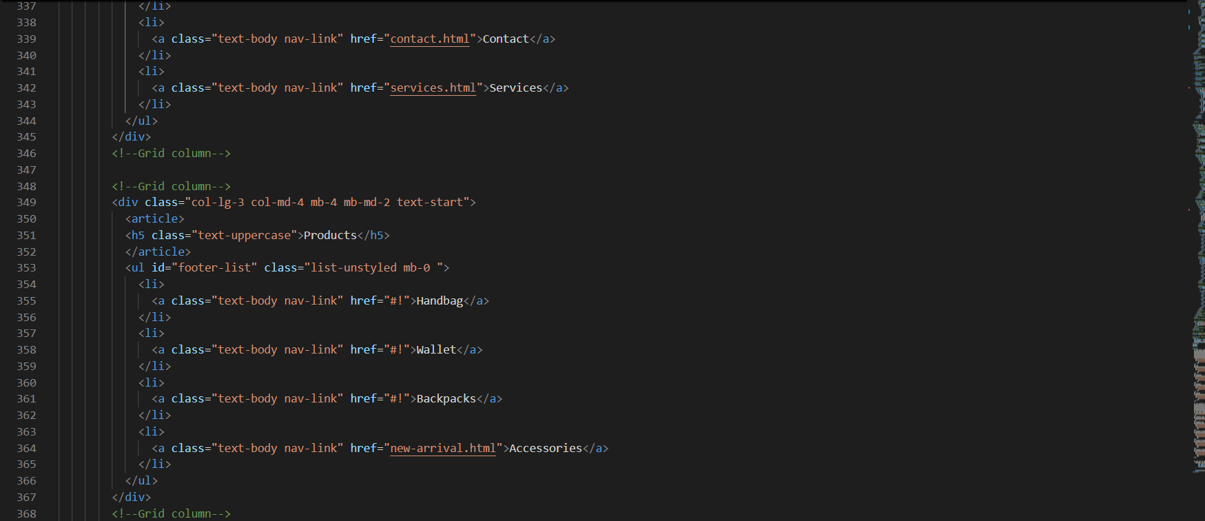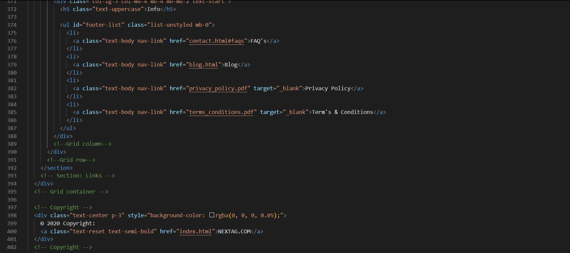

# ABOUT PAGE:

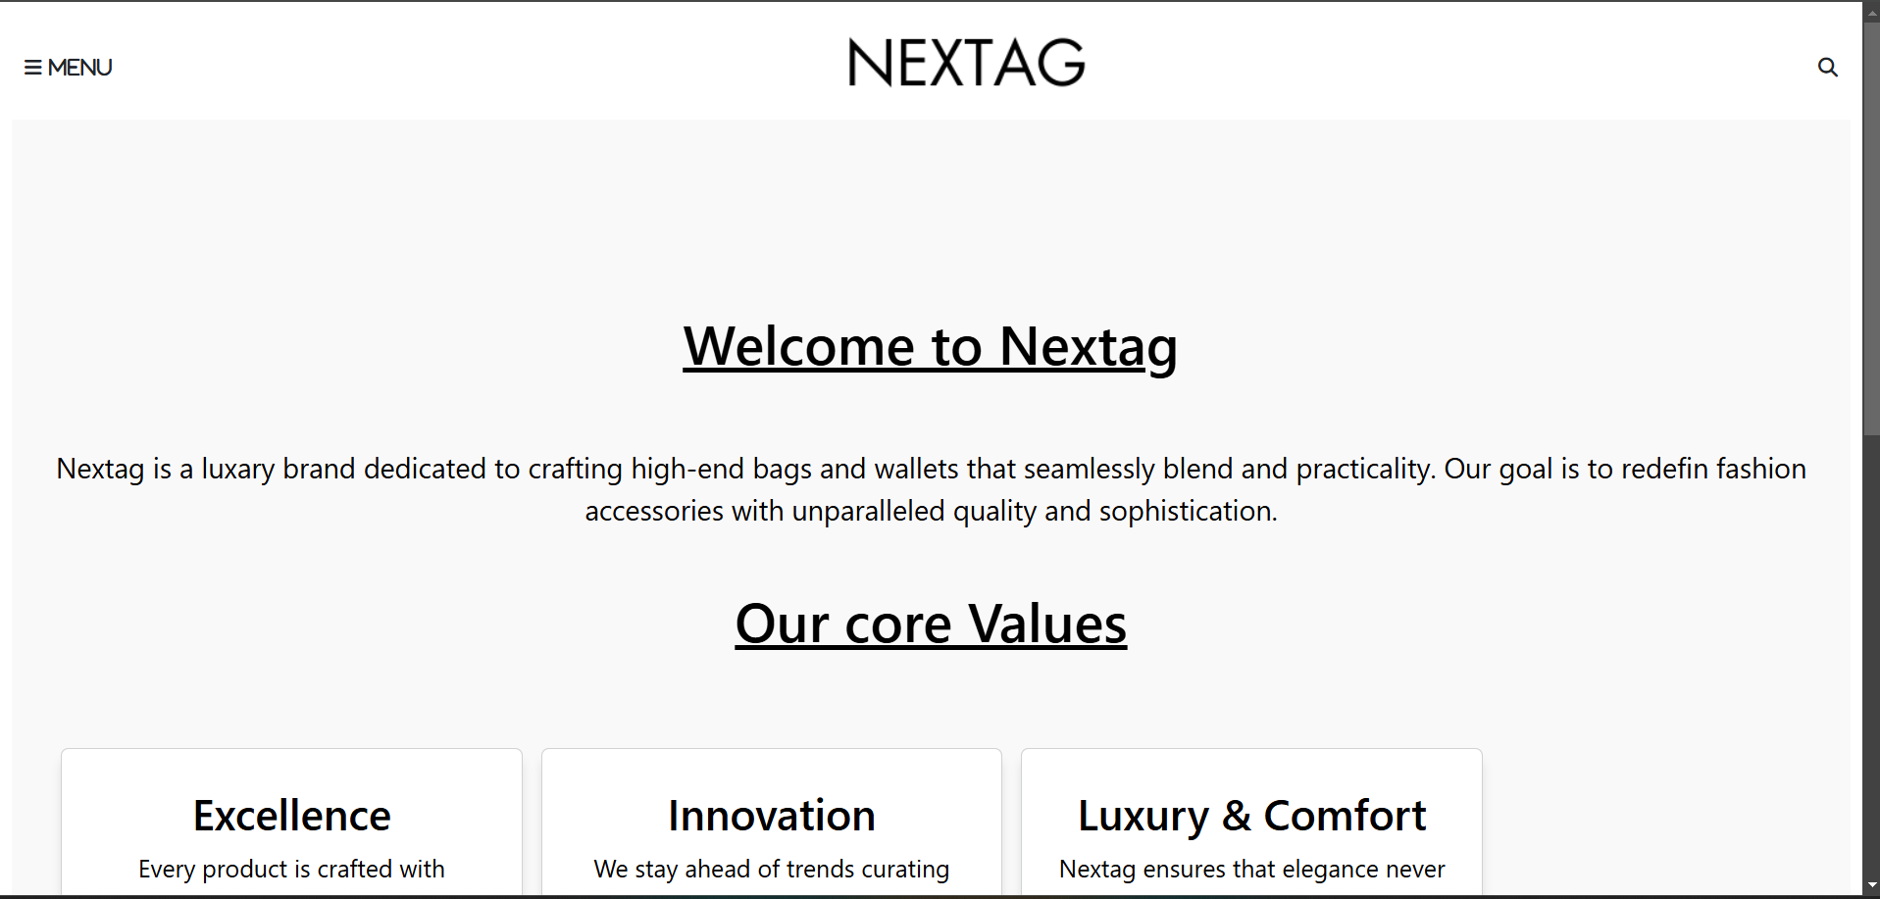

About page, where you can learn about our mission and values. We are dedicated to innovation and impactful service.

# Code Of About Page:

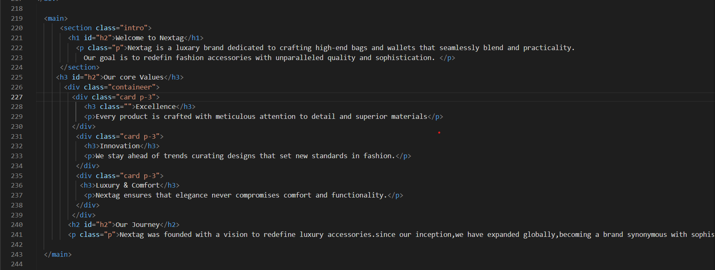

# Contact Page:

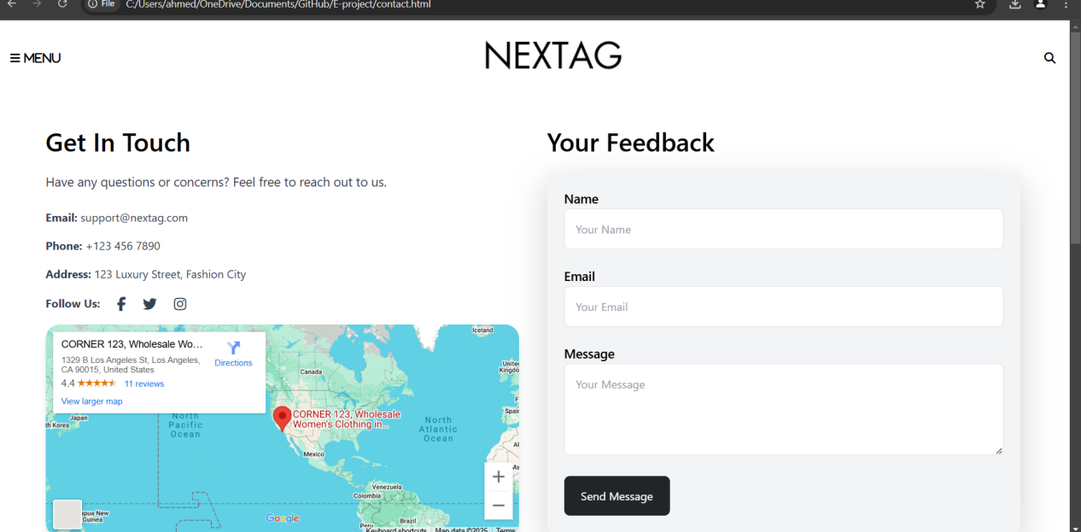

A contact page is an essential part of any website, providing visitors with key information to reach out to the organization or individual. It typically includes:

* **Email address**: For inquiries and support.
* **Phone number**: For immediate assistance.
* **Physical address**: For mailing or visits, if relevant.
* **Contact form**: To allow direct messages through the website.

Additionally, it may feature**social media links**for informal contact and an**FAQ section**to address common questions. A well-designed contact page enhances user engagement and builds trust with visitors.

# Code of Contact Page:

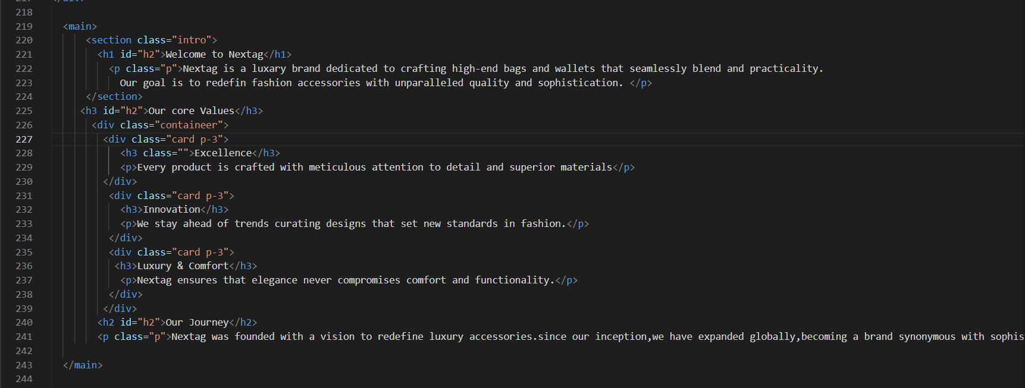

# CHECK-OUT PAGE:

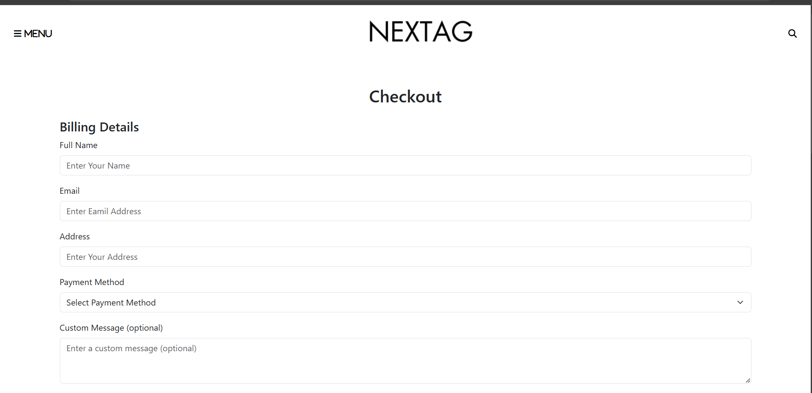

* **Secure shopping cart system.**
* **Multiple payment options (PayPal, Credit Card, etc.).**

# ****Code of check out page:****

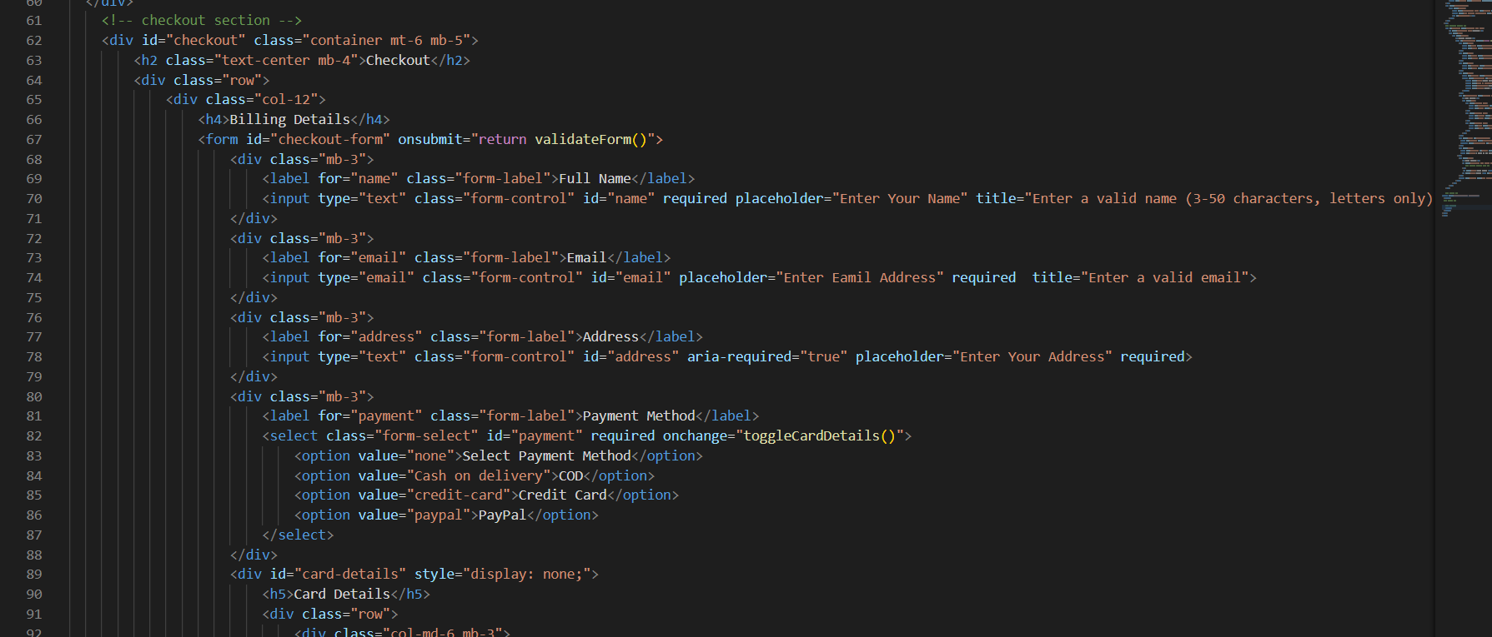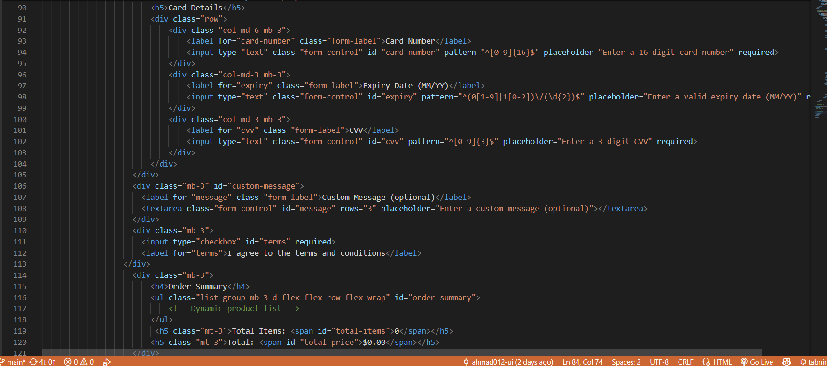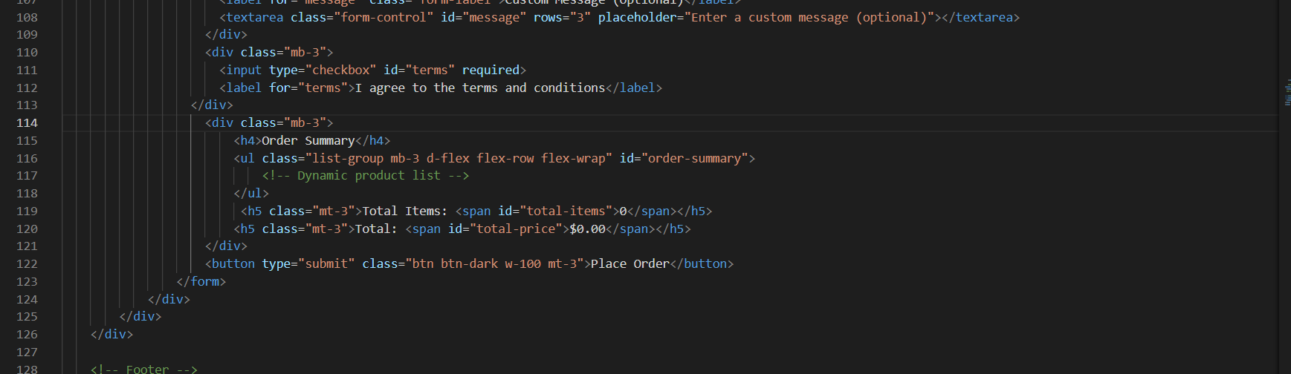

# BLOG PAGE:

# Screenshot 2025-03-15 221924

A blog page is a section of a website featuring informal content on specific topics, encouraging reader interaction and engagement.

# Code of Blog page:

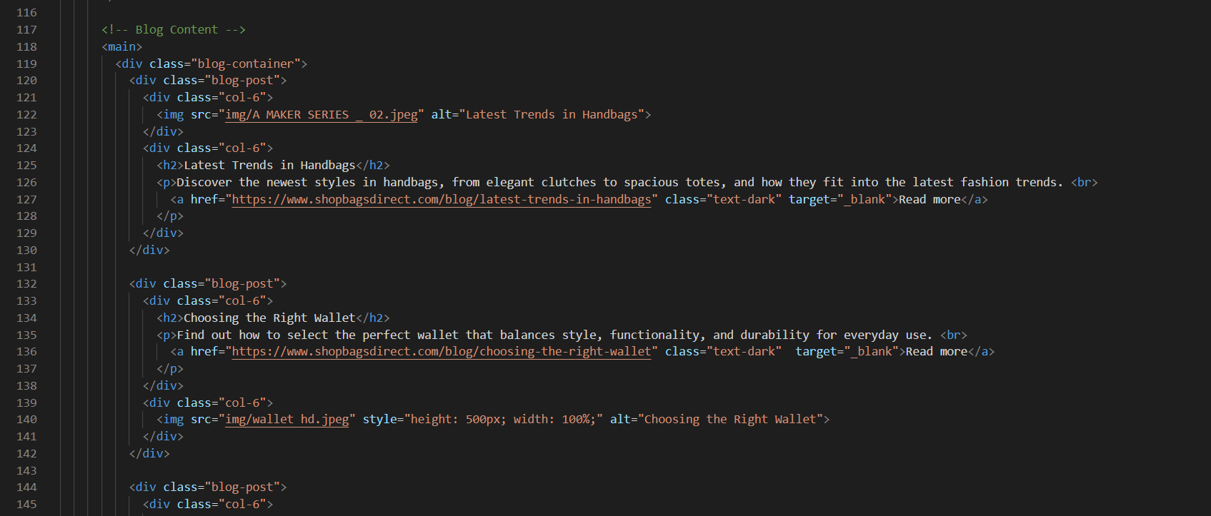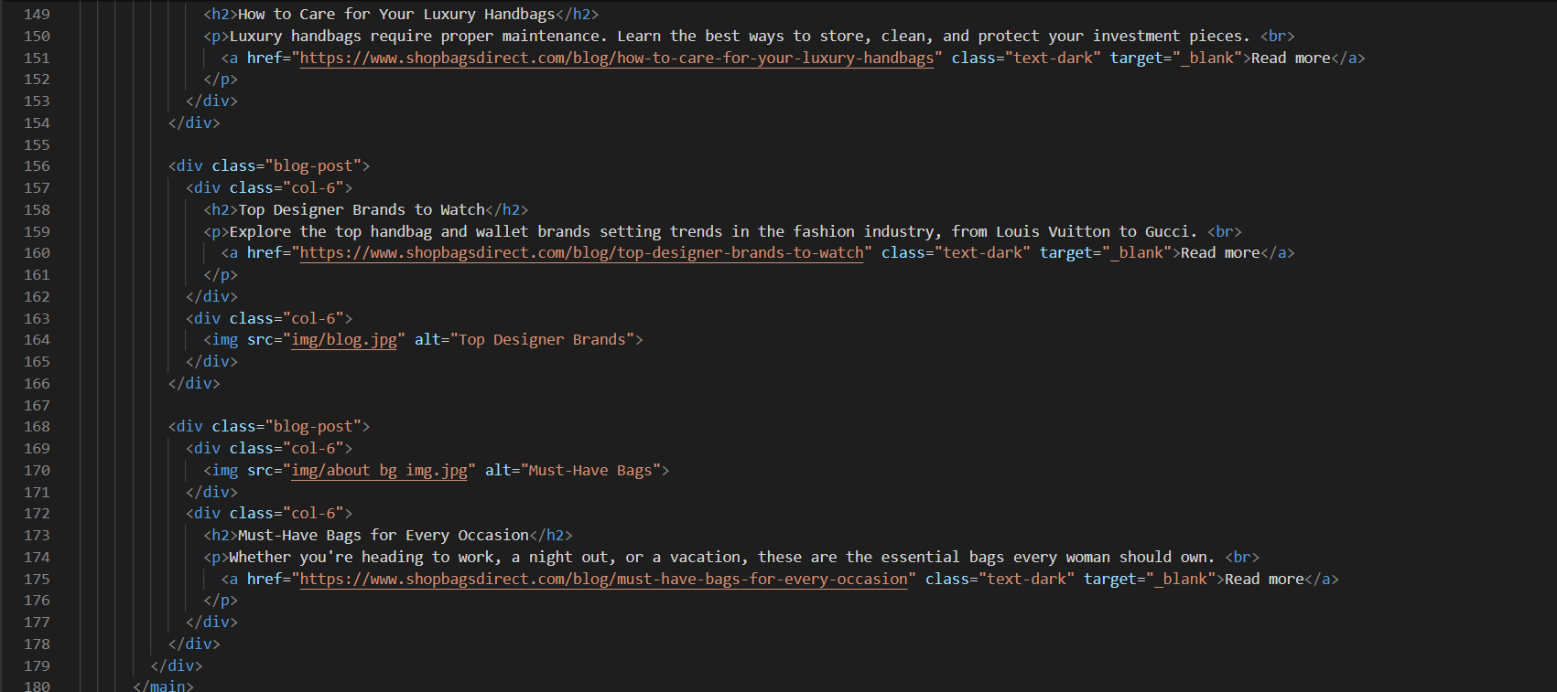

SERVICES PAGE:

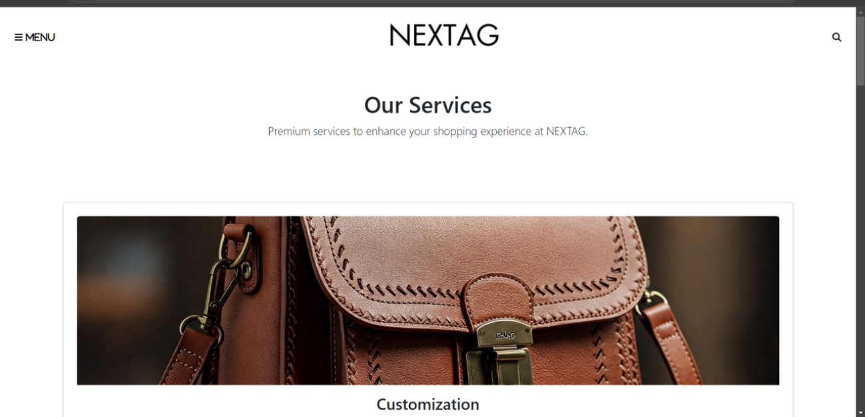

A service page typically contains essential information about the offerings, including descriptions, pricing, and contact details, all presented in a clear and concise manner.

# CODE OF SERVICE PAGE:

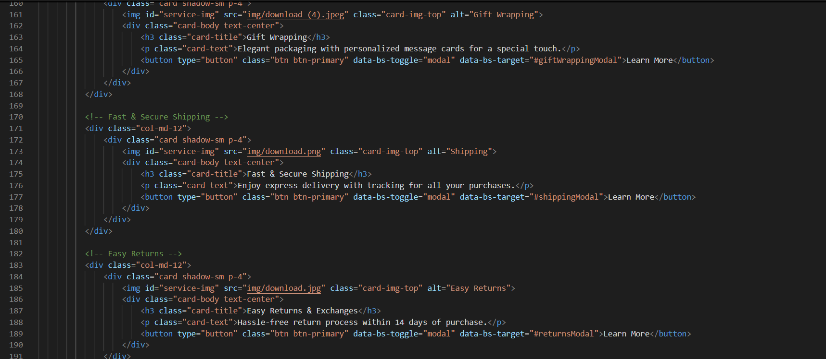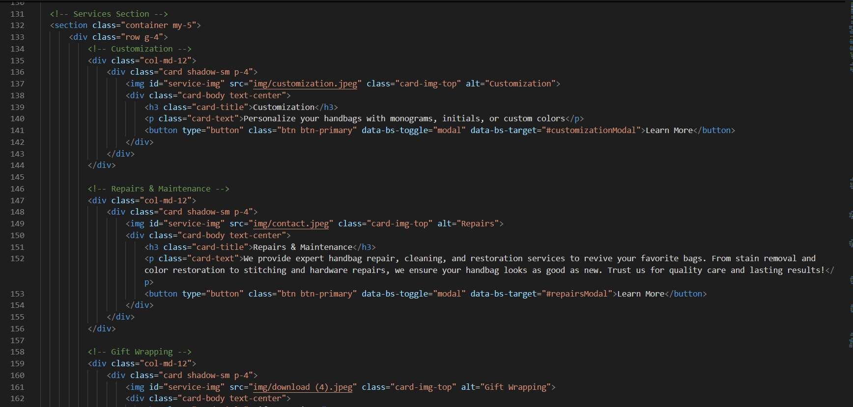

NEW ARRIVAL PAGE:

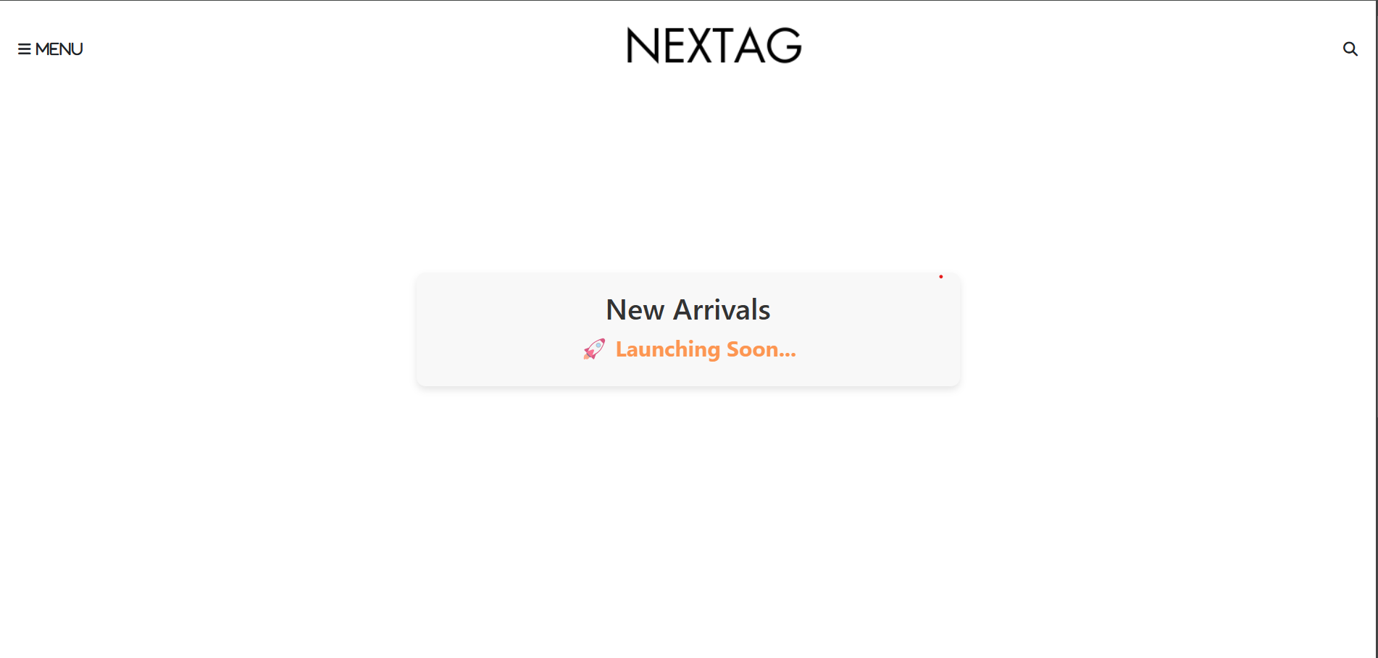

THIS PAGE IS FOR NEW ARRIVALS WHICH IS GONNA BE ACCESSORIES WHICH’LL BE LAUCHING SOON

CODE:

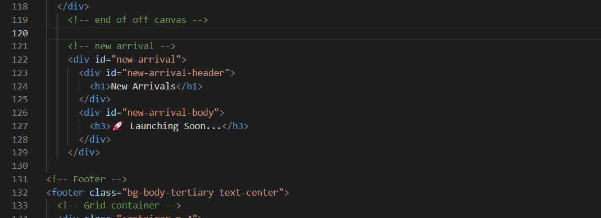

SHOP PAGE MEN;

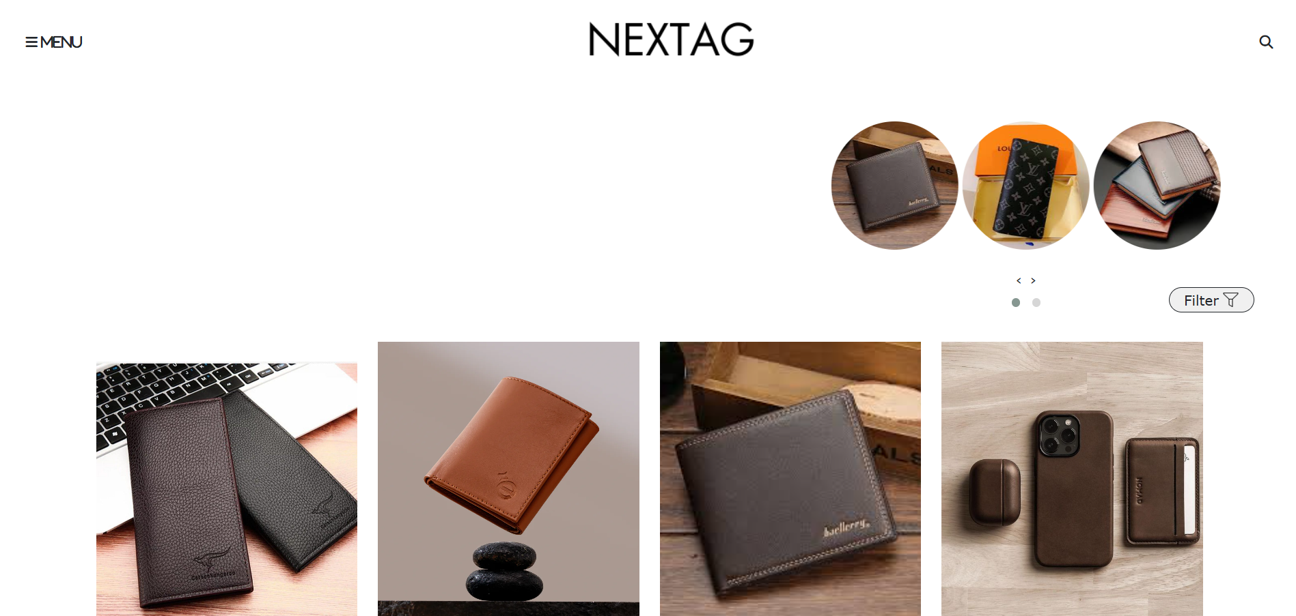

Code;

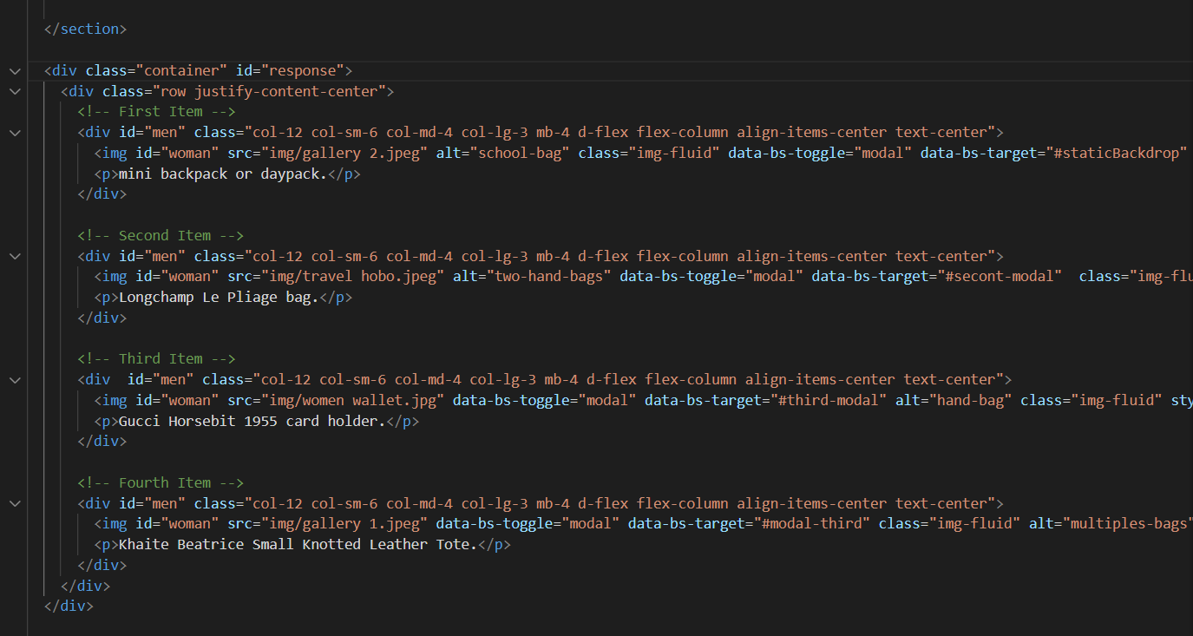

SHOP PAGE WOMEN;

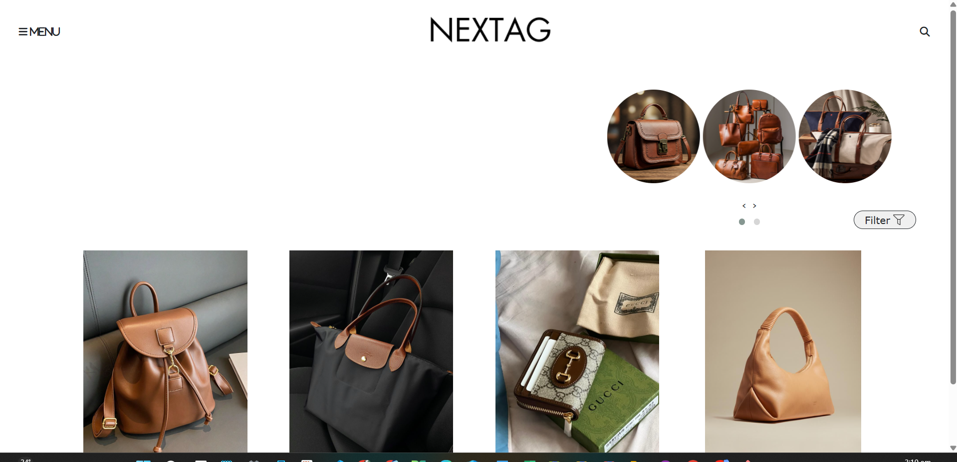

# CODE;

# 